Matthew Tran
USB Drive Partitioning & Memory Layout Analysis
In this lab, I’ll do two things: first, I’ll prepare a USB drive for use in Linux by partitioning, formatting, and mounting it, then examine its file system details. Second, I’ll look at how a C program uses memory, stepping through code with a debugger to see how functions and variables are stored on the stack.
Tools Used
- Linux terminal
- dmesg
- fdisk
- mkfs (ext4 and vfat)
- dumpe2fs
- mount / umount
- gcc compiler
- size command
- objdump
- GDB debugger
- gedit text editor

Skills Learned
- Partitioning a USB drive using fdisk
- Formatting partitions with ext4 and vfat file systems
- Mounting and unmounting storage devices in Linux
- Analyzing file system details using dumpe2fs
- Compiling C programs and examining their memory layout with size and objdump
- Using GDB to set breakpoints, step through code, and inspect the call stack
- Understanding stack frames and function-level memory management
- Debugging C programs to observe variable behavior and execution flow
Task 1) Partitioning, Formatting, and Mounting USB Stick on Linux
In this part of the lab, I learned how to prepare a USB stick for use in a Linux environment by partitioning, formatting, and mounting it. This process is essential for managing storage devices in Linux and understanding how file systems work.
- Check if the device was mounted
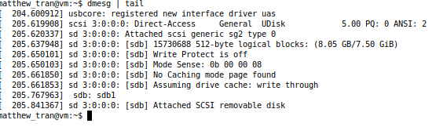
dmesg | tail
The dmesg | tail command shows the last few lines of the system’s logs, including information about newly attached devices. This step helps identify the device name of the USB stick.

- If the USB is mounted automatically, unmount it:
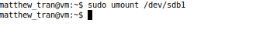
sudo umount /dev/sdb1
If the device is automatically mounted, we’ll need to unmount it using unmount to prevent data corruption during partitioning. This ensures that no processes are accessing the USB drive while you make changes to its partitions.

- Partition the USB stick:
sudo fdisk /dev/sdb1
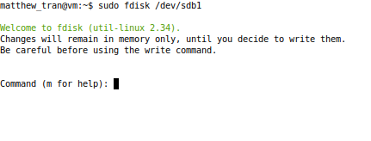
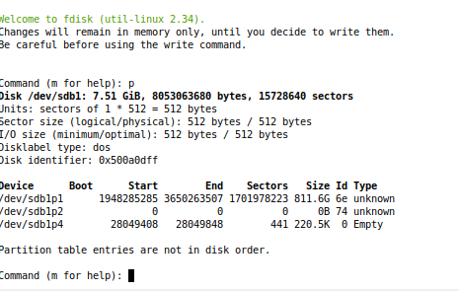
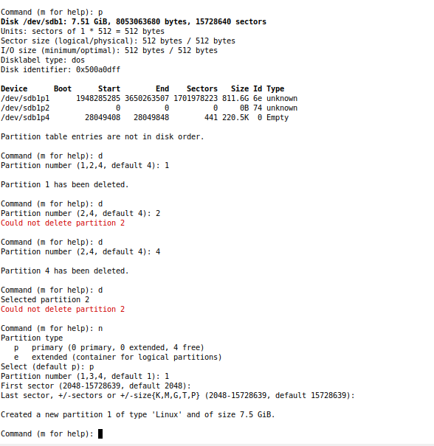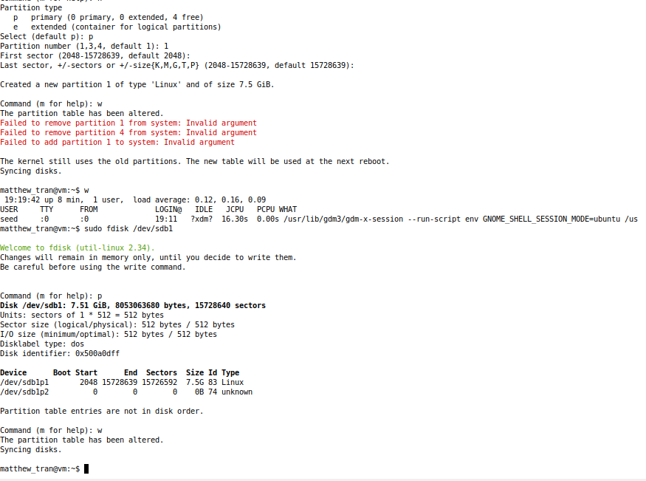
Inside the fdisk tool:
Type p to display current partitions.
Type d to delete the existing partition.
Type n to create a new partition.
Type p to select a primary partition.
Type 1 to assign it as the first partition.
Press Enter to accept the default starting and ending locations.
Type w to save the partition table and exit fdisk.
The fdisk command is used to create or modify partitions on the USB stick. Partitioning prepares the USB stick for formatting by defining a specific area on the device where a file system can stay/be found.

- Format the new partition:
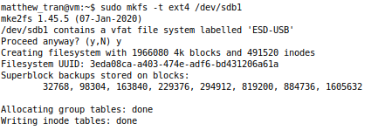
sudo mkfs -t ext4 /dev/sdb1
The mkfs -t ext4 command creates a new ext4 file system on the partition, which is the format used by Linux. This step is necessary to prepare the USB stick for use with Linux by orgainizing its storage according to the ext4 format.

- Create a mount point:
mkdir mediatest1
The mkdir command creates a directory (mount point) where the USB stick’s file system can be attached to the Linux directory structure. This is necessary because Linux requires a mount point to access files on an external device.

- Mount the new file system:
sudo mount -t ext4 /dev/sdb1 mediatest1
Check if the mount was successful:
ls mediatest1
The mount command attaches the USB stick’s file system to the mount point we’ve created. This allows us to interact with the USB stick's files and directories.
- Check file system details: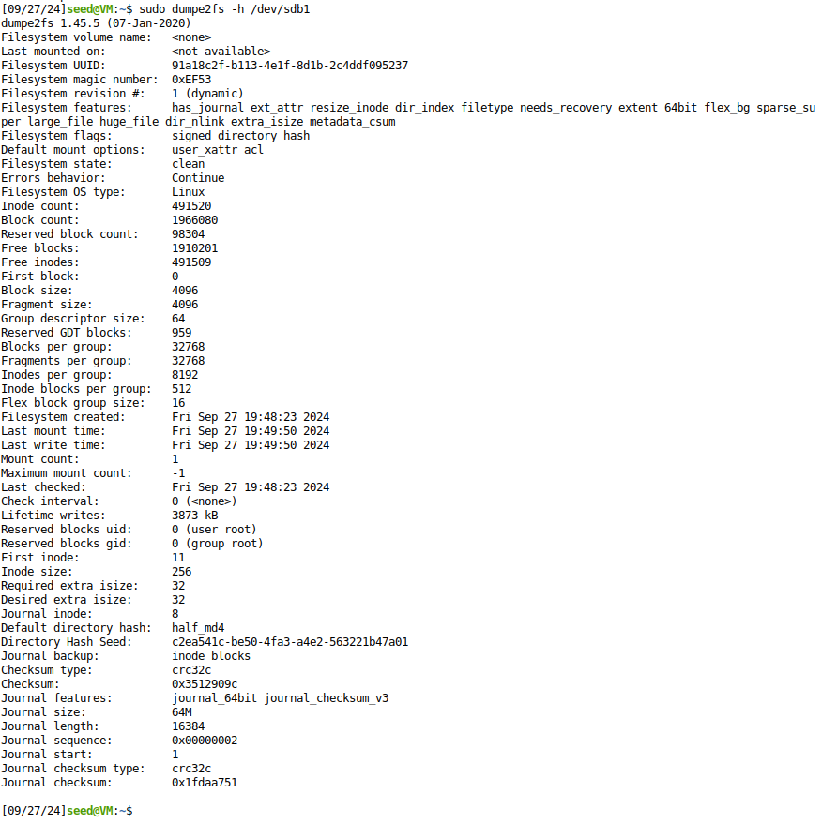
sudo dumpe2fs –h /dev/sdb1
The dumpe2fs command provides detailed information about the ext4 file system, including block size, reserved blocks, and inode structure. It is used to analyze the file system’s internal structure and attributes.
has_journal: The filesystem uses a journal to keep track of changes before writing them to the disk. Journaling helps recover from crashes more easily.

ext_attr: This feature supports extended attributes (xattrs), which are name/value pairs that can be associated with files and directories for storing metadata.
resize_inode: Enables the filesystem to be resized dynamically. A special inode is reserved for future resizing.
dir_index: Directories are indexed using a hash tree. This speeds up lookups in large directories.
filetype: This feature stores the file type in the directory entry itself, making directory lookups more efficient.
needs_recovery: Indicates that the filesystem needs recovery via the journal (if a crash happened, the journal will be replayed).
extent: Enables the use of extents (instead of the older block-mapping system). Extents are larger, contiguous blocks of storage and improve performance for large files.
64bit: The filesystem can handle 64-bit block numbers, allowing support for very large filesystems (more than 16 TB).
flex_bg: Flex block groups improve allocation flexibility, meaning files are not tied to specific block groups, increasing performance and disk space usage efficiency.
sparse_super: Reduces the number of superblock backups, which saves space on large filesystems.
large_file: Supports large files larger than 2 GB.
huge_file: Supports files larger than 2 TB.
dir_nlink: Allows directories to contain more than 32,000 subdirectories, increasing the limit from the ext3 filesystem.
extra_isize: The inode size is larger than the standard 128 bytes, allowing extra metadata to be stored in inodes.
metadata_csum: Protects metadata with checksums, ensuring filesystem integrity.

- Unmount the USB device:
sudo umount /dev/sdb1
This step safely detaches the USB stick from the mount point, ensuring all data is written to the device before removal. It prevents data corruption by ensuring no files are being accessed during device removal.

- Reformat to Windows format :
To return the USB stick to a Windows-readable format, you can either use:
sudo mkfs.vfat /dev/sdb1
or, use the Windows format tool in File Manager.
The mkfs.vfat command or Windows format tool converts the file system back to FAT32 (VFAT), which is readable by both Windows and Linux. This step is necessary if you want to use the USB stick on a Windows machine again.

Task 2) Memory Layout and the Stack
gedit hello_world-1.c
This command opens a file called hello_world in the gedit text editor.
- Program 1: hello_world-1.c:
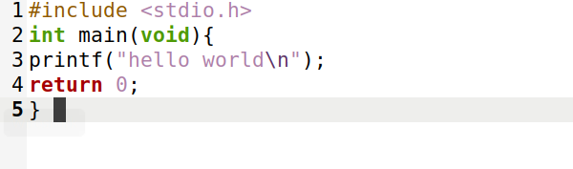
#include <stdio.h>
int main(void){
printf("hello world\n");
return 0;
}
- Compile and link the program:
gcc -W -Wall -c hello_world-1.c
gcc -o hello_world-1 hello_world-1.o
The gcc -W -Wall -c and gcc -o commands compile and link the C program hello_world-1.c into an executable. This step transforms your C code into machine code that can be executed by the computer.

- Use size to examine the memory layout:
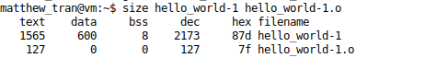
size hello_world-1 hello_world-1.o
The size command shows the memory segments (text, data, bss) of both the object file and the executable. This is used to see how much memory is occupied by different sections of the program.
- Use objdump to inspect object file sections:
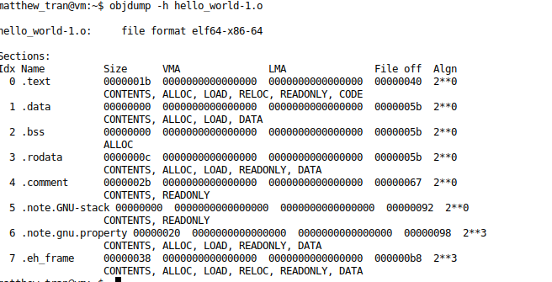
objdump -h hello_world-1.o
The objdump -h command provides details about each section (text, data, etc.) within the object file. This helps to understand the memory layout at the assembly level and provides a more in-depth view of memory usage.
- Program 2: hello_world-2.c:
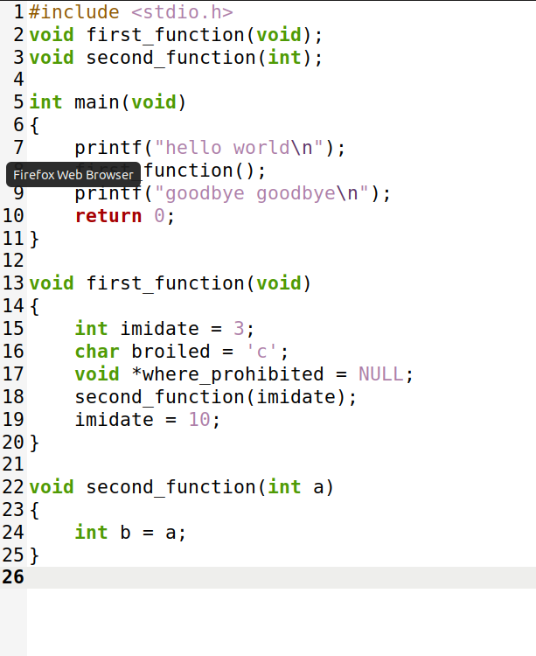
#include <stdio.h>
void first_function(void);
void second_function(int);

int main(void)
{
printf("hello world\n");
first_function();
printf("goodbye goodbye\n");
return 0;
}

void first_function(void)
{
int imidate = 3;
char broiled = 'c';
void *where_prohibited = NULL;
second_function(imidate);
imidate = 10;
}

void second_function(int a)
{
int b = a;
}
- Compile the program:
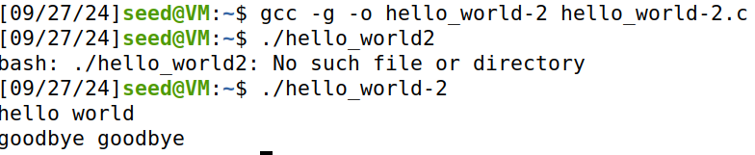gcc -g -o hello_world-2 hello_world-2.c

- Start GDB with the program:
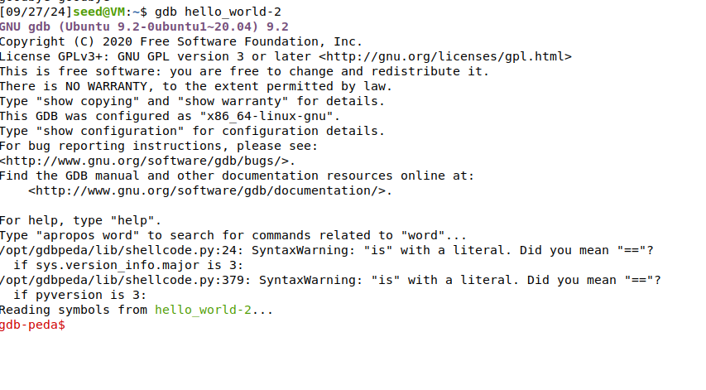
gdb hello_world-2
- Set breakpoints:
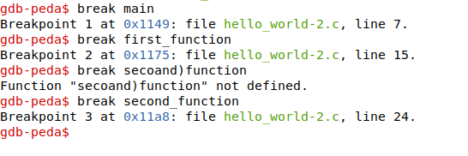
(gdb) break main
(gdb) break first_function
(gdb) break second_function
Using gdb hello_world-2 and setting breakpoints (gdb break main, gdb break first_function, etc.) allows you to control where the program pauses during execution. This is used to step through the program line by line and examine the stack frames at each function call.

- Runs the program
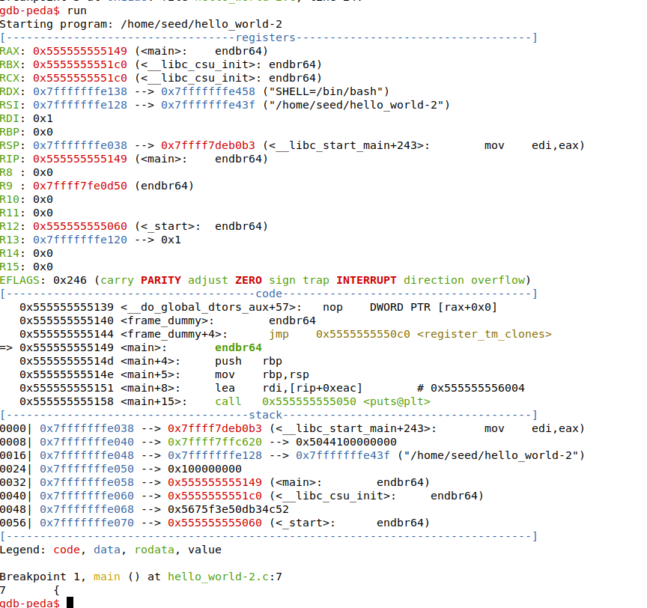
(gdb) run
- View the call stack:
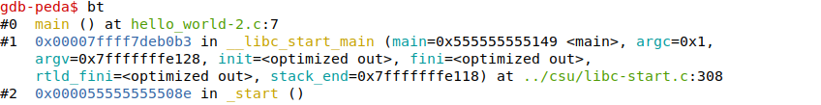(gdb) bt
Running the program in GDB with gdb run stops at the first breakpoint, and the bt (backtrace) command lets you view the sequence of function calls (stack frames). This is important for understanding how function calls are stacked in memory and how variables are handled.
- code line by line:
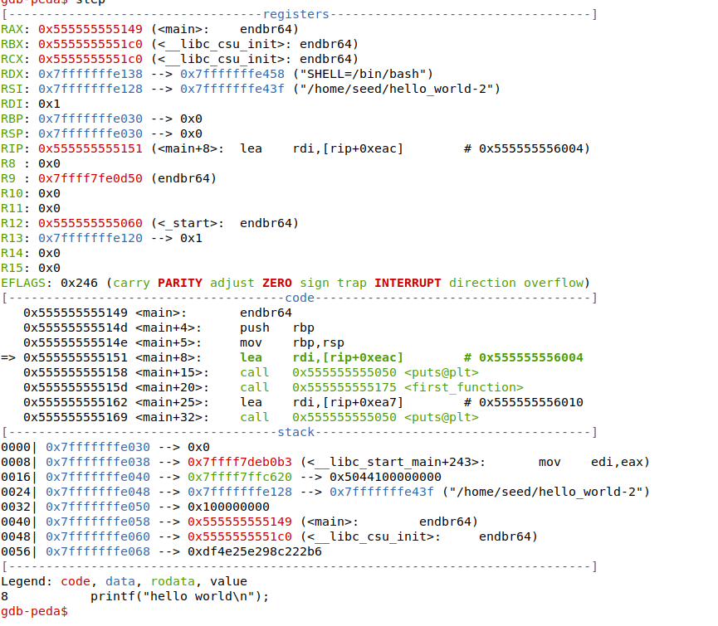
(gdb) step
- Print the value of imidate in first_function:
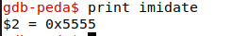
(gdb) print imidate
The step command allows you to execute the program one line at a time, while print imidate shows the value of the local variable in the current function. This helps in visualizing how variables and function calls interact within the stack.
13. Quit GDB:
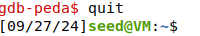
(gdb) quit
After you have finished stepping through the code and examining the memory, use the quit command to exit GDB. This ends the debugging session and returns you to the command line.

